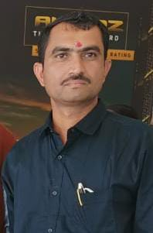

**Leadership**

Mr. Deepak K. Aher (Founder President & Managing Director)

Qualification: B.A & Diploma (Animal Husbandry); Diploma (Yoga & Naturopathy).

Mr. Deepak K. Aher is a founder and Apex managerial person of Vasundhara Sanstha’s Higher Managements team and provides directions and guidance to executive team. He having good business sense under stressed circumstances. He interact and collaborate with other likeminded functionaries for leveraging resources .His core responsibilities are as Administration, HR, PRO, Banking, Legal, Audit & Taxation. Presently he is having additional charge of CSR Activities. He ensures collaboration for shared goals along with interacting with higher management for reporting. ….

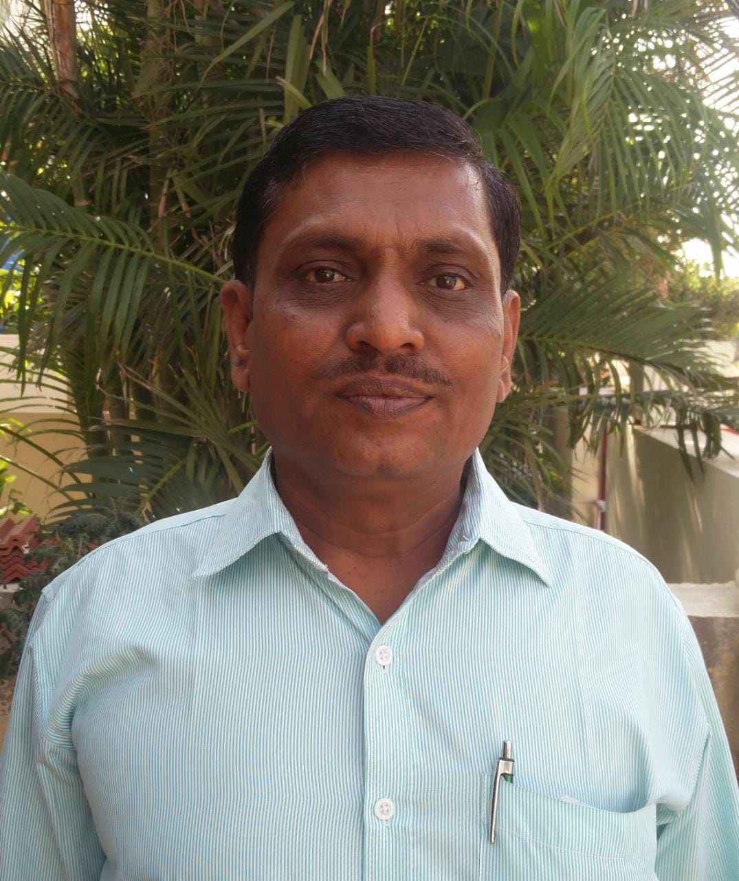

Mr Dilip V: Handore ( CO-FOUNDER, CONSULTANT & MENTOR)

M.Sc. (Biophysics Bio-Medical Instrumentations) M.B.A. (Finance) M.P. P. Tech.

He is having responsibilities of planning & directing along with monitoring and to take corrective actions whenever necessary. He directs senior Managers, Supervisors & project head coordinators.

His core responsibilities are as, to ensure clarity around priorities and goal for the entire functional

area. Approving request for investments, managing financial budgeting, Interacting and communicating financial, legal & technical and also monitor key performance indicators accordingly to direct reports to ensure the goal cascade to all Managers. He handles Complex & Critical Scenarios….

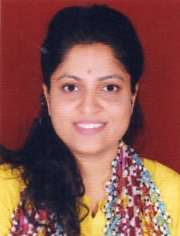

Dr. Anita V. Handore,(Co-Founder, H.O.D. (R&D, Environment &Bio Technology, AYUSH)

Qualification: Ph.D.(Microbiology)M.Phil(Environmental Science)

Dr.Anita Handore is Vasundharas Most Senior most personality. She is handling one of most complex

And Challenging activities of Vasundhara sanstha, With respect to the Sustainable technologies & it's implications of poverty eradication by delivering Appropriate technology through R&D and its technology transfer. She supervises & monitors respective work and takes corrective actions when necessary, she is working across functions with peers in-house constants groups to ensure results and goals. She guides for talent identification & development process. ….

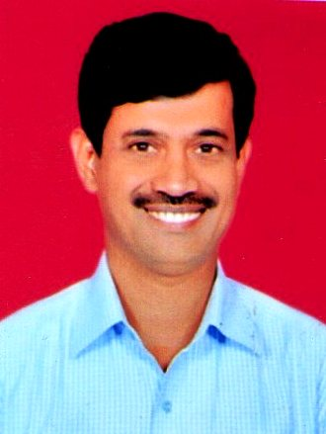

Name :- Dr.Vijay V.Kadam (Trusty & Project Director -AYUSH & Community Health )

Qualification: B.A.M.S.(Ayurveda & Surgery) Diploma (Yoga & Naturopathy)

Dr.Vijay Kadam is key managerial person is handling Vasundhara Sanstha’s social Healthcare activities as per goals and objectives ,he design & develop policies for community health project with respect to its implications of poverty eradication by delivering his knowledge & expertise experience.

He supervises & monitor respective work and take corrective actions when necessary, He is working across functions with peer’s outhouse health groups & professionals to ensure results and goals.

He guides for respective AYUSH health practitioners talent identification & its development process. ….

**Board of Trustees**

|  |  |  |  |  |
| --- | --- | --- | --- | --- |
| **Sr.No.** | **Name of Trustee** | **Designation** | **Contact** | **Photo** |
| **1** | **Mr.Deepak K.Aher** | **President** | 9422905549 | C:\Users\Sairam\AppData\Local\Microsoft\Windows\Temporary Internet Files\Content.Word\IMG-20221005-WA0030.jpg |
| **2** | **Mrs. Pushapa M.Wagh** | **Vice-President** | 9423483591 | C:\Users\Sairam\AppData\Local\Microsoft\Windows\Temporary Internet Files\Content.Word\img796.jpg |
| **3** | **Mr.Nilesh P.Dusane** | **Secretory** | 9226161378 | C:\Users\Sairam\AppData\Local\Microsoft\Windows\Temporary Internet Files\Content.Word\img797.jpg |
| **4** | **Mr.Tushar N.Wagh** | **Director** | **9420165008** |  |
| **5** | **Mr.Dr.Vijay V.Kadam** | **Director** | 8600158800 | G:\Sanstha Member ID\Vijay Kadam\dr kadam.jpg |
| **6** | **Mr.Bhusan N.Dalvi** | **Director** | 7755912871 | C:\Users\Sairam\AppData\Local\Microsoft\Windows\Temporary Internet Files\Content.Word\img795.jpg |
|  |  | **Director** |  |  |